Week 2 Internship Report
Computer Networking Fundamentals
Submitted By

Name: Krina Sorathiya
Internship: DG Interns Hub
Week: 2
Submission Date: 14th August 2026
Intern Id: DG/JULY/CYBER/049

TABLE OF CONTENTS:

No. | Topic
1 | Introduction
2 | Task 1 – Ports & Services
3 | Task 2 – Networking Devices
4 | Task 3 – Network Security Basics
5 | Task 4 – Packet Analysis using Wireshark
6 | Task 5 – Network Scanning using Nmap
7 | Task 6 – Packet Tracer LAN Setup
8 | Task 7 – Safe MITM Concept Simulation
9 | Learning Outcomes
10 | Conclusion

1. Introduction
1.1 Overview:
The objective of Week 2 of the DG Interns Hub Cybersecurity Internship was to develop practical knowledge of advanced networking concepts, network traffic analysis, basic network scanning, and security attack concepts.
During this week, I studied common network ports and services, learned the functions of routers, switches, and firewalls, and explored basic network security concepts such as Man-in-the-Middle (MITM), Denial of Service (DoS), and packet sniffing.
I also performed practical activities using Wireshark, Nmap, and Cisco Packet Tracer.

1.2 Objectives:
The main objectives of this week were:
- Understand common TCP and UDP ports.
- Learn about important network services.
- Understand the working of routers, switches, and firewalls.
- Understand basic network security concepts.
- Analyze real network traffic using Wireshark.
- Identify DNS and HTTPS-related traffic.
- Perform authorized network scanning using Nmap.
- Identify open ports and services.
- Create a basic LAN using Cisco Packet Tracer.
- Test communication using ping.
- Understand MITM attacks safely and conceptually.

2. TASK 1 – PORTS & SERVICES
2.1 Introduction
A network port is a logical communication endpoint used by applications and services to communicate over a network.
Ports are identified by numbers from 0 to 65535.
The two major transport protocols are:
- TCP – Transmission Control Protocol
- UDP – User Datagram Protocol
TCP provides reliable, connection-oriented communication, while UDP provides faster, connectionless communication with less overhead.
Understanding common ports is important for cybersecurity because security professionals use port information to identify running services and understand the attack surface of a system.

2.2 Common Ports and Services :

Port | Protocol | Service | Usage
20 | TCP | FTP Data | Transfers file data
21 | TCP | FTP | FTP control connection
22 | TCP | SSH | Secure remote access
23 | TCP | Telnet | Remote terminal access
25 | TCP | SMTP | Sending email
53 | TCP/UDP | DNS | Domain name resolution
67 | UDP | DHCP Server | Provides IP configuration
68 | UDP | DHCP Client | Receives IP configuration
69 | UDP | TFTP | Simple file transfer
80 | TCP | HTTP | Web communication
110 | TCP | POP3 | Receiving email
123 | UDP | NTP | Time synchronization
135 | TCP | MS RPC | Windows RPC communication
139 | TCP | NetBIOS | Windows network communication
143 | TCP | IMAP | Email access
161 | UDP | SNMP | Network monitoring
389 | TCP/UDP | LDAP | Directory services
443 | TCP | HTTPS | Secure web communication
445 | TCP | SMB | File and printer sharing
3389 | TCP | RDP | Remote desktop access

2.3 Security Importance
Open ports are not automatically vulnerabilities. However, an unnecessary or incorrectly configured service can increase the attack surface.
Security professionals should:
- Identify open ports.
- Identify running services.
- Disable unnecessary services.
- Keep services updated.
- Restrict access using firewalls.
- Monitor unusual network activity.

3. TASK 2 – NETWORKING DEVICES

3.1 Router:
A router is a networking device that connects different networks and forwards packets between them.
Routers primarily use IP addresses to determine where packets should be sent.
- Working:
When a router receives a packet:
- It examines the destination IP address.
- It checks its routing information.
- It determines the appropriate next hop/interface.
- It forwards the packet toward the destination.
Real-World Example:
- A home Wi-Fi router connects devices such as smartphones and computers to the Internet.

3.2 Switch:
- A switch connects multiple devices within a local network.
- A switch primarily works with MAC addresses.
Working:
- The switch learns the MAC addresses of connected devices and stores them in a MAC address table.
- When it receives an Ethernet frame, it checks the destination MAC address and forwards the frame through the appropriate port.
Real-World Example:
In an office, a switch can connect:
- Computers
- Printers
- Servers
- Access points
- Other network devices
3.3 Firewall:
A firewall is a network security device or software that monitors and controls network traffic according to security rules.
A firewall can allow or block traffic based on:
- IP address
- Port
- Protocol
- Application
- Connection state
- Security rules
Real-World Example
A company firewall may allow HTTPS traffic on port 443 while blocking unauthorized inbound connections.
3.4 Router vs Switch:
Feature | Router | Switch
Main purpose | Connects different networks | Connects devices within LAN
Address | IP address | MAC address
Typical OSI Layer | Layer 3 | Layer 2
Main function | Packet forwarding | Frame forwarding
Example | LAN to Internet | PCs in office LAN
Network type | Connects networks | Local network connectivity
4. TASK 3 – NETWORK SECURITY BASICS
4.1 What is Network Security?
Network Security is the practice of protecting network infrastructure, devices, applications, and data from unauthorized access, misuse, disruption, interception, and modification.
Network security helps maintain:
- Confidentiality
- Integrity
- Availability
These are the major principles of the CIA Triad.
4.2 Man-in-the-Middle (MITM)
A Man-in-the-Middle attack occurs when an attacker positions themselves between two communicating parties.
Normal:
- User A ─────────── User B

MITM:
- User A ─── Attacker ─── User B
The attacker may attempt to observe or modify communication.

Real-World Example:
An attacker operating or controlling an insecure public Wi-Fi environment could potentially attempt to interfere with users' communications.
Risks
- Data interception
- Credential exposure
- Session interception
- Communication modification
- Privacy loss
Prevention:
- Use HTTPS.
- Use secure Wi-Fi.
- Use VPN where appropriate.
- Validate security certificates.
- Avoid sensitive activity on suspicious networks.
- Use strong encryption.
4.3 Denial of Service (DoS):
A Denial of Service attack attempts to make a service unavailable to legitimate users.
An attacker may attempt to exhaust:
- Bandwidth
- CPU resources
- Memory
- Network connections
- Application resources
A distributed version is called DDoS, where traffic or requests originate from multiple systems.
Prevention:
- Traffic filtering
- Rate limiting
- Network monitoring
- Redundancy
- DDoS protection
- Capacity planning
4.4 Packet Sniffing:
Packet sniffing means capturing and analyzing network packets.
It is a legitimate technique when performed with authorization, for example:
- Network troubleshooting
- Security monitoring
- Incident investigation
- Protocol analysis
However, unencrypted network traffic may expose sensitive information.
Prevention:
- HTTPS
- TLS encryption
- VPN
- Secure protocols
- Avoid unsecured networks

5.TASK 4 – PACKET ANALYSIS USING WIRESHARK

5.1 Introduction:
- Wireshark is a network protocol analyser that allows users to capture and inspect network traffic.
It can be used to analyze:
- DNS
- TCP
- UDP
- HTTP
- HTTPS/TLS
- ICMP
- IP traffic

5.2 Practical Steps:
Step 1 – Open Wireshark
Open Wireshark and select the active network interface.
Step 2 – Start Capture
Start packet capture.
Step 3 – Generate Traffic
Open a web browser and visit a website such as:
- google.com
Step 4 – Stop Capture

Return to Wireshark and stop the packet capture.
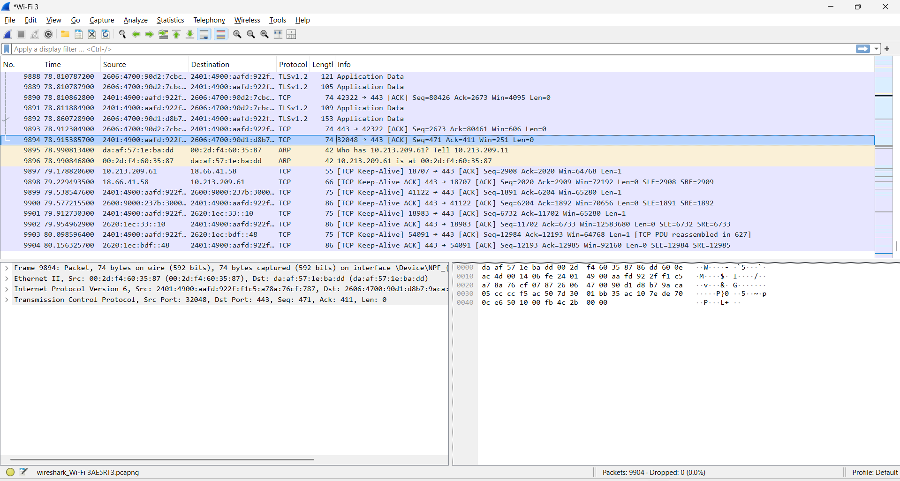
Step 5 – Analyze DNS
Use the filter:
- Dns
Step 6 – Analyze HTTPS
Use:
- tcp.port == 443
This helps identify TCP traffic associated with HTTPS.
Step 7 – Analyze IP Addresses
Use:
- ip
and inspect the source and destination addresses.
5.3 DNS Analysis:
- During the packet analysis, DNS traffic was observed.
The observed traffic included:

Domain:
chatgpt.com
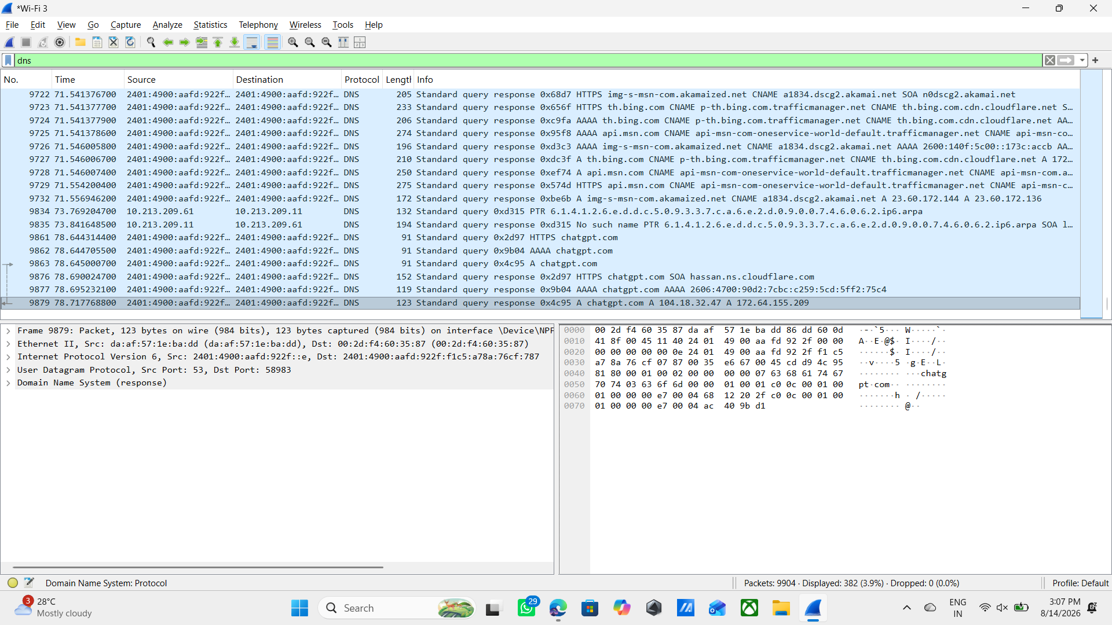
Observed IPv4 responses:
104.18.32.47
172.64.155.209
Observation:
DNS helps convert a human-readable domain name into an IP address so that network communication can take place.

5.4 HTTPS/TCP Analysis:
A TCP packet associated with port 443 was analyzed.
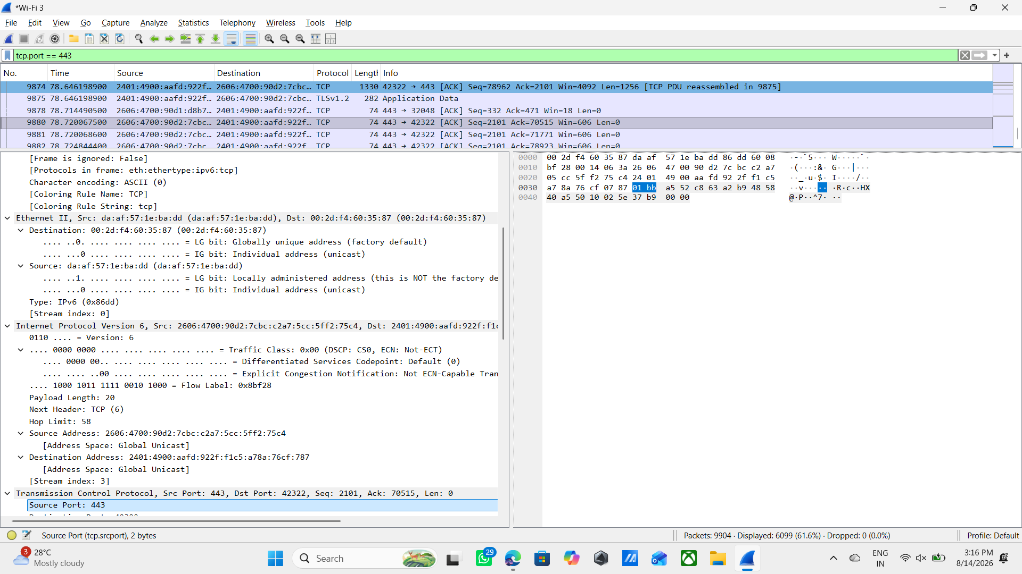
Example observation:
Field | Value
Protocol | TCP
Source Port | 443
Destination Port | 42322
Address Type | IPv6

The observation demonstrates that modern web communication can use IPv6 as well as IPv4.

5.5 Source and Destination IP:
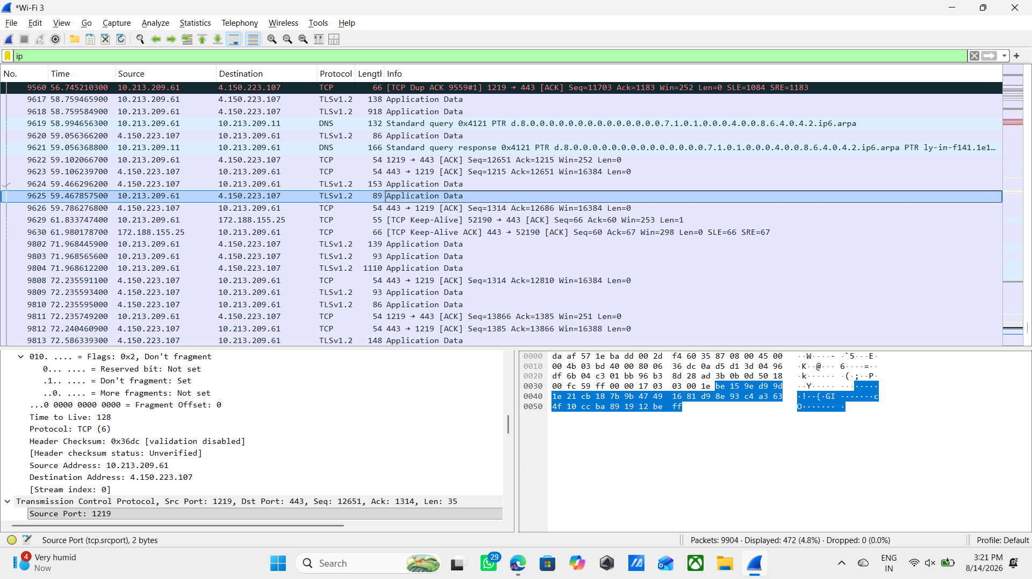
An IPv4 packet was also inspected.
Field | Observed Value
Source IP | 10.213.209.61
Destination IP | 4.150.223.107
Protocol | TCP
Source Port | 1219
Destination Port | 443

Conclusion:
- Wireshark successfully provided visibility into network packets, protocols, IP addresses, ports, and DNS activity.

6. TASK 5 – NETWORK SCANNING USING NMAP
6.1 Introduction:
- Nmap (Network Mapper) is a network scanning tool used to discover hosts, identify open ports, and obtain information about network services.
- For this internship, scanning was performed only against the authorized training target:
- scanme.nmap.org

6.2 Basic Nmap Scan:
Command:
- nmap scanme.nmap.org
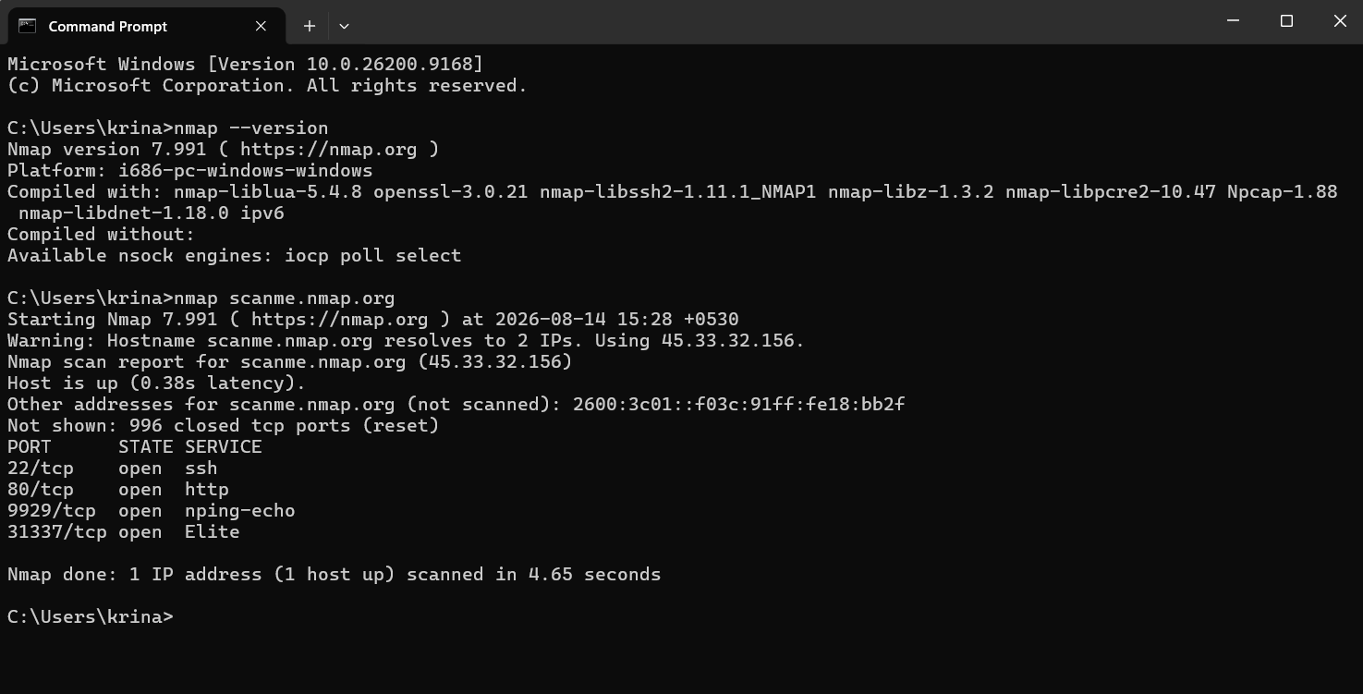
Purpose:
The basic scan is used to identify open TCP ports on the target.
Observed Target
IP Address: 45.33.32.156
Host Status: Up

Open Ports :
Port | State | Service
22/tcp | Open | SSH
80/tcp | Open | HTTP
9929/tcp | Open | Nping Echo
31337/tcp | Open | Elite

6.3 Service Version Detection:
Command:
- nmap -sV scanme.nmap.org
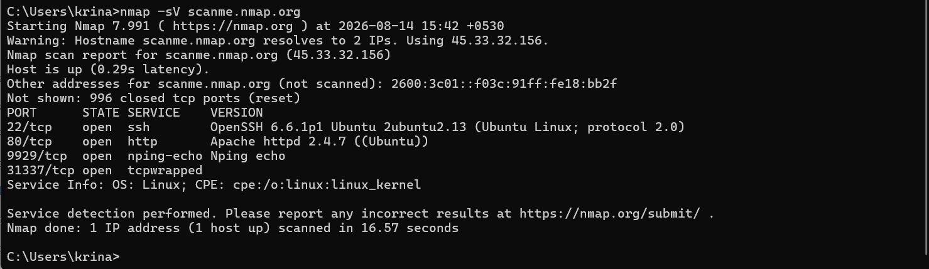
The -sV option attempts to identify the services and versions associated with discovered open ports.
Purpose:
Service detection helps security professionals understand what software/services are exposed on a system.
6.4 Ethical Consideration:
Network scanning should only be performed on systems for which permission has been provide d.
For this assignment, the authorized training target was used.

TASK 6 – CISCO PACKET TRACER LAN SETUP
7.1 Objective:
The objective was to create a simple LAN using:
- 2 PCs
- 1 Switch
Topology:
PC1 ───────── Switch ───────── PC2
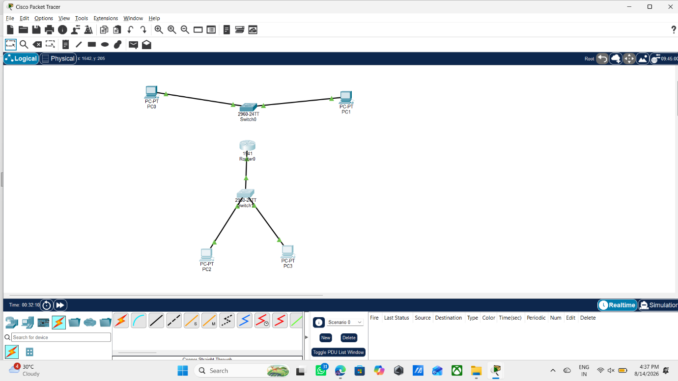

7.2 IP Configuration:
PC1
IP Address: 192.168.1.10
Subnet Mask: 255.255.255.0
PC2
IP Address: 192.168.1.11
Subnet Mask: 255.255.255.0
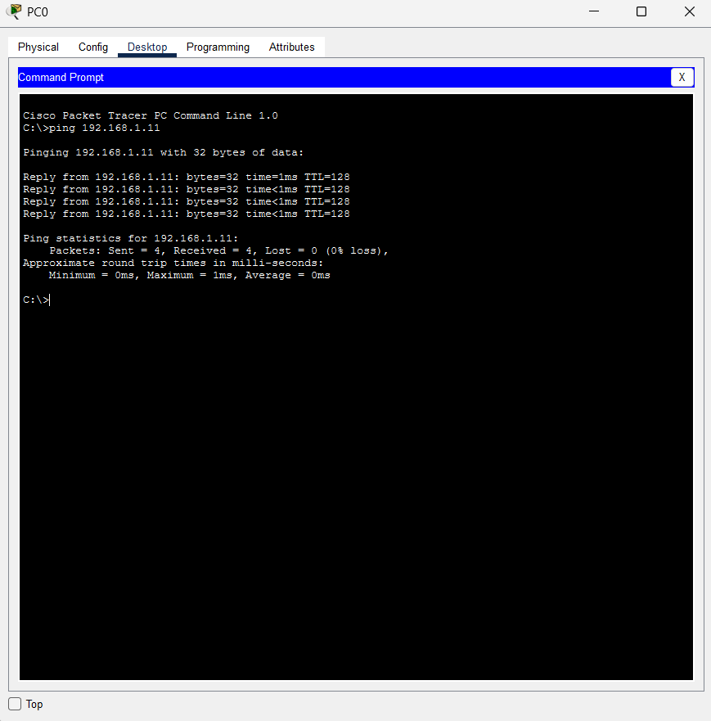

7.3 Connection:
The PCs were connected to the switch using appropriate Ethernet connections.
After configuring the IP addresses, connectivity was tested using the ping command.
7.4 Ping Test
From PC1:
ping 192.168.1.11
The ping test was successfully completed.
Result
Sent = 4
Received = 4
Lost = 0
Conclusion
PC1 and PC2 were successfully able to communicate with each other through the switch.

8. TASK 7 – SAFE MITM CONCEPT SIMULATION
8.1 Objective
The objective of Task 7 was to understand the concept of a Man-in-the-Middle attack in a safe and controlled environment.
No real-world interception or credential capture was performed.

8.2 Topology:
The topology included:
- PC1 – Victim
- PC2 – Attacker/Concept Node
- Switch
- Router
Conceptual structure:
Router
│
Switch
/ \
PC1 PC2
Victim Concept Node


8.3 IP Configuration
Device | Role | IP Address
PC1 | Victim | 192.168.1.10
PC2 | Attacker/Concept | 192.168.1.20
Router | Gateway | 192.168.1.1
Subnet Mask:
255.255.255.0
8.4 Router Configuration
The router interface was configured with:
192.168.1.1
and subnet mask:
255.255.255.0
The interface was enabled using the appropriate router configuration.

8.5 Connectivity Test
From PC1:
ping 192.168.1.1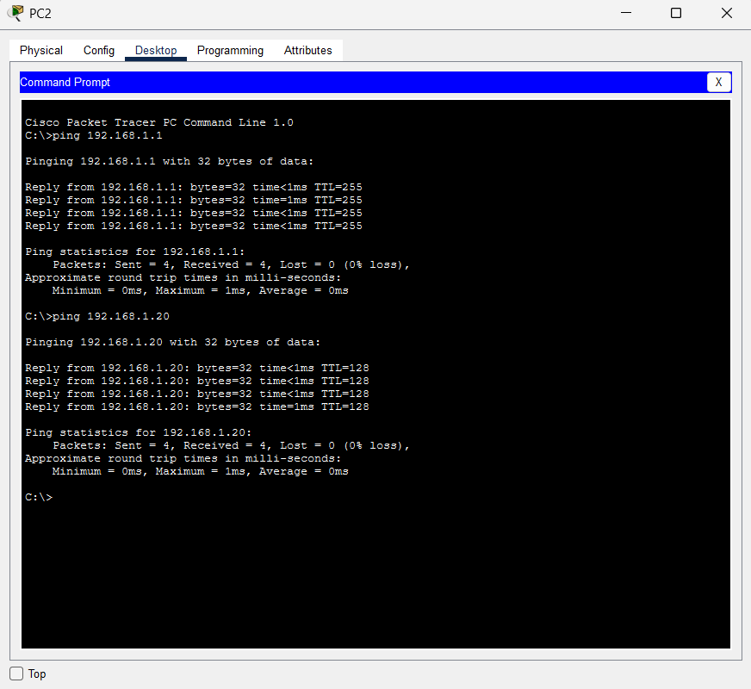

The router ping was successful.
This confirmed that PC1 could communicate with the configured gateway.

8.6 MITM Concept
In a conceptual MITM scenario, the attacker attempts to position themselves between the victim and the intended destination.
The attacker may potentially attempt to:
- Observe communication
- Intercept information
- Modify traffic
- Steal sensitive data
However, this internship practical only demonstrates the concept and does not perform actual interception.
8.7 Real-World Example:
A common example is an insecure public Wi-Fi network.
If a user connects to an untrusted network, an attacker may attempt to interfere with network communication.
Using encrypted protocols such as HTTPS significantly reduces the risk of exposing the contents of communications.

8.8 MITM Prevention:
Important prevention methods include:
- HTTPS
- TLS encryption
- VPN
- Secure Wi-Fi
- Strong authentication
- Certificate validation
- Avoiding suspicious public networks

9. LEARNING OUTCOMES
After completing Week 2, I gained practical knowledge of:
Networking
- TCP and UDP
- Ports and services
- IP addressing
- MAC addresses
- Routers
- Switches
- Firewalls
Network Analysis
- Packet capture
- DNS analysis
- TCP/HTTPS traffic
- Source and destination IP analysis
Security
- MITM attacks
- DoS attacks
- Packet sniffing
- Basic prevention techniques
Practical Tools
- Wireshark
- Nmap
- Cisco Packet Tracer
Troubleshooting
I also gained experience in checking IP configuration, verifying network connections, troubleshooting connectivity issues, and testing communication using ping.
10. CONCLUSION
The DG Interns Hub Week 2 assignment provided practical exposure to networking and cybersecurity fundamentals.
Through the theory tasks, I learned about common ports, services, networking devices, and network security concepts.
Through practical activities, I used Wireshark to analyze network traffic, Nmap to perform authorized network scanning, and Cisco Packet Tracer to create and test network topologies.
The assignment also helped me understand how network security concepts such as MITM, DoS, and packet sniffing relate to real-world cybersecurity.
Overall, Week 2 improved my understanding of networking, network analysis, security concepts, troubleshooting, and responsible use of cybersecurity tools.

